Project 60 Data Model
The following concepts are represented (entities are written without the leading civicrm_) :
entity name | shortcode | description
bank_transaction | BTX | an individual movement in a bank statement (for a semantic discussion on the terms payment, refund, ... see the detailed description of this entity)
bank_account | BA | an individual bank account
bank_account_reference | BAR | an external reference for an individual bank account
bank_transaction_batch | BTXB | a set of bank transactions, typically from a single bank statement

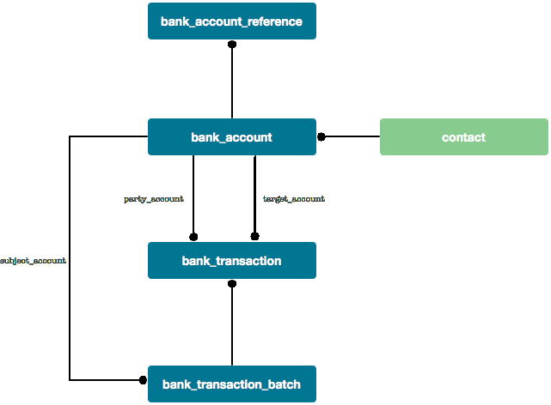

civicrm_bank_transaction
Represents a single bank transaction, ie. an entry in the communication from the bank concerning things that happen to the bank account. Could be a money transfer into/out of the BA, a message saying there is interest to be booked, ...
field | type | key | description
id | int(11) | PK | unique auto-incrementing reference
ba_id | int(11) | FK | link to civicrm_bank_account.id (internal / target / recipient account)
type_id | int(11) | FK | links to a type (one of a set of btxtypes)
value_date | date |  | describes the moment the value of this transaction was added to the BA balance
booking_date | date |  | execution date of the transaction
amount | decimal(20,2) |  | amount of the BTX
currency | varchar(3)
status | int(11) | FK | link to a set of status values : new, identified, processed, ignored
data_raw | text |  | the complete information that was received for this BTX
data_parsed | text |  | a JSON-formatted array of decoded fields (built by the specific plugin)
party_ba_id | int(11) | FK | link to civicrm_bank_account:id if there is a second party involved in the BTX (typically in case of transfer type BTX)
sequence | int(11) |  | a relative reference inside its originating source batch (requires the batch to be identified)
tx_batch_id | int(11) | FK | to the originating batch (not sure whether the batch_entity does not take care of this)
bank_reference | varchar(64) |  | a unique external reference used by the bank, stored for reconciliation and integrity maintenance purposes. Every import plugin MUST provide such a reference, even if it generates a hash value of sorts.

v2 might have a n:n link between types and transactions, effectively implementing some sort of tagging. If we are able to create a tagset that is used for BTX, we could directly use this functionality (using entity_tag). Either way, for now, the API/BAO can return the types as an array of one.

civicrm_bank_account
Most bank_account records will describe parties (ie. people paying money to the organization). They will have the basic fields :

field | type | key | description
id | int(11) | PK | unique auto-incrementing reference
data_raw | text |  | the information found in the latest BTX relating to this BA (typically as a party) describing the identity/ies of its owner(s), like address information
data_parsed | text |  | a JSON-formatted array of decoded fields (built by the specific plugin)
contact_id | int(11) | FK | link to civicrm_contact:id describing the owner of the BA
created_date | date
modified_date | date
description | varchar(255) |  | a human readable description of the BA, eg.'Online donation account'

In Belgium, bank statements contain address info, but other countries have different practices. We'll remove the address_id previously modeled for two reasons : (1) we can store it in the parsed blob and (2) CiviCRM addresses are currently hardwired to link to a contact, and we do not want to create another type of contact for a bank account.

The description will mainly be useful for managed bank accounts (accounts for which bank input is expected), but may also be used to allow a donor to 'name' their accounts using an online account profile.

civicrm_bank_account_reference
We will allow for different references for a single bank account (such as IBAN, BIC and BBAN), so we'll use a table which maps n:n with references / type tuples.

field | type | key | description
id | int | PK | unique auto-incrementing reference
reference | varchar(64) |  | the reference with which the BA is identified (IBAN, BBAN, ...)
reference_type | int |  | the type of account reference (IBAN, BBAN, BIC ...) from an enum value
ba_id | int | FK

civicrm_bank_transaction_batch

Information coming from banks
We'll assume every set of transactions belongs to a sort of bank statement. This ensures we maintain some form of integrity of the data. Bank statements will typically be easy to wrap in this model. Manual input of a bank statement would be a case similar to an imported bank statement.
field | type | key | description
id | int(11) | PK | unique auto-incrementing reference
issue_date | datetime |  | when the statement was issued
reference | varchar(32) |  | human readable version of the statement reference (if available)
sequence | int |  | used by the import plugin responsible for maintaining integrity
starting_balance | decimal(20,2)
ending_balance | decimal(20,2)
tx_count | int
starting_date | datetime |  | used for user identification / documentation purpose only
ending_date | datetime |  | ditto
currency | varchar(3)

Information from accounting systems
Exports from accounting systems may or may not work with a sequence validation. The main difference is that contrary to a bank statement, the group itself does not contain validation information to avoid duplicates.

Import channels and integrity
We will use a model similar to the payment processor pattern, allowing for a channel instance for each of the managed accounts. This channel is responsible for ensuring integrity (worst case, using the bank_reference field). Each instance will be able to maintain a context, for instance, the last statement read, ...

For instance, an organization which has three bank accounts could have this setup :

Account | Name/use | Plugin type | Parameters
12874612-09 | Fundraising account | CODA22 | - config blob  - folder containing new files  - folder containing processed files  - status blob  - most recent statement number  - last account balance  - weight : 100
12874433-86 | Operations account | CODA22 | - config blob  - folder containing new files  - folder containing processed files  - status blob  - most recent statement number  - last account balance  - weight: 80
47838405-77 | Event account | CSV | - config blob  - field separator  - contains labels or not  - weight: 10

The types could be defined as follows :

Plugin type | Name/use | Plugin Classname
CODA22 | Belgium CODA format v2.2 | CBI_Plugin_Coda22
CSV | Comma Separated Value file | CBI_Plugin_Csv

